RETIRED AND VETERAN eMKayans Membership Form

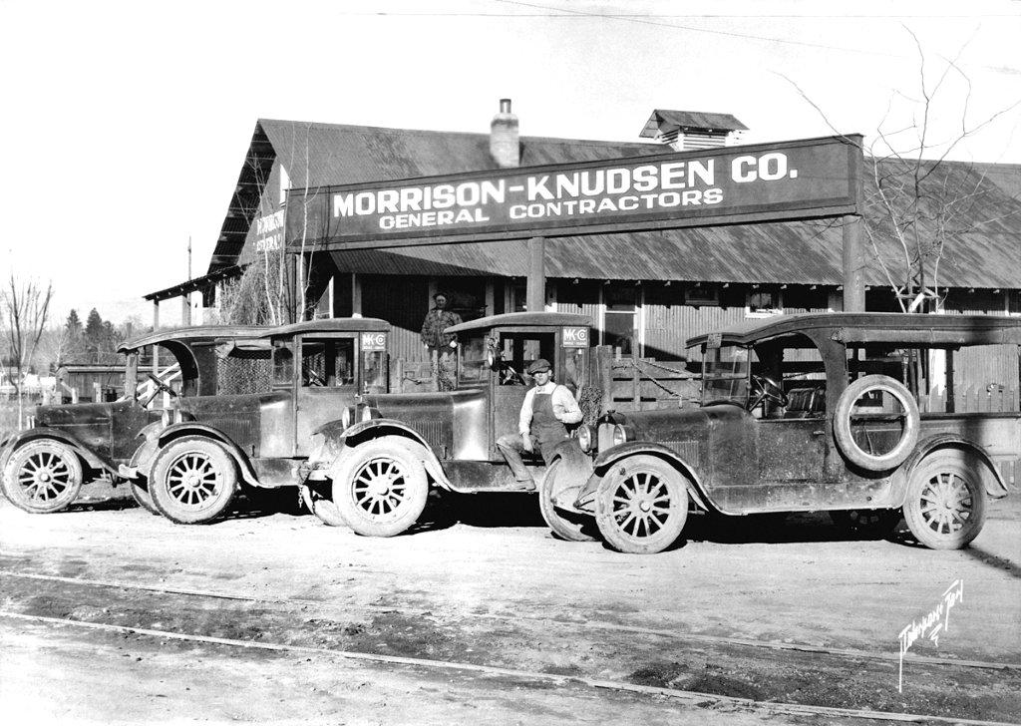

Please complete this registration form and return it with your check to:
Jay Gould
12823 W. Grenadier Dr.
Boise, ID 83713

REGISTRATION FORM

Member Name_____________________________________

Email Address_____________________________________

Mailing Address ___________________________________

___________________________________

Phone (optional): __________________________________

Annual Dues – (Postage, Printing, Envelopes, etc.) $5.00 $ 5.00

Total Enclosed $_______
(Please make checks payable to “Veteran eMKayans”
Mail to: Jay Gould 12823 W. Grenadier Drive, Boise, ID 83713) □ Dues are enclosed

